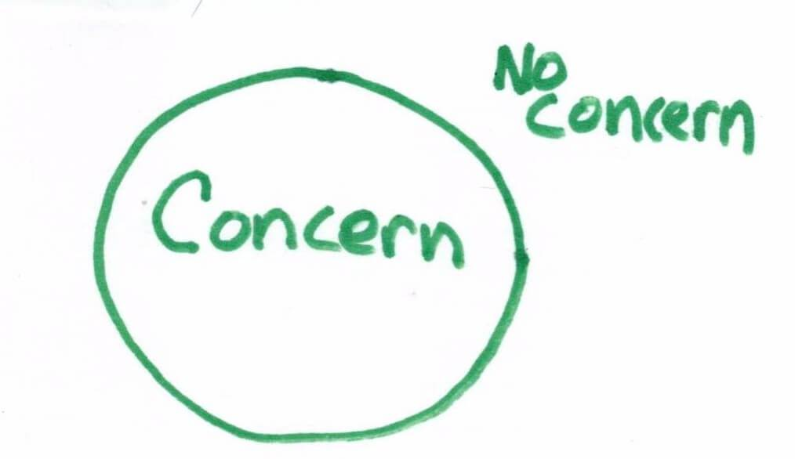

**How Do I Tell Someone I Have a *Problem?***

Telling someone what might not be working and what worries you in your residential placement is a good thing.

We want you to talk with us about what is happening in your placement so that we can improve how we take care of you.

**You can tell your Problem or Concern or make a Complaint to an adult if:**

* You *Disagree or are Not Happy*  with the way you are being taken care of,
* You’re *Worried* about the way another person in your home - a kid or a staff - is treating you,
* You feel something should be provided to you and it isn’t, or
* You want your staff or foster parent to help you solve your problem your way and not their way.

How Do I Tell Someone if I Have a Problem?

## It’s OK to Make a Complaint



|  |  |
| --- | --- |
| **Step One**  If you are comfortable, talk about the problem or complaint with someone you trust or the other person involved. See if you can solve the problem. | **Step Two**  Ask for a copy of the ‘I Have a Concern Form’ to fill out. You can ask for help from someone you choose to help fill the form out. |

**\*If you need more help, please ask for it \***

**\*\* You can call the Provincial Advocate’s Office at any time\*\***

|  |  |
| --- | --- |
| When this form is done you can give it to:   |  | | --- | | **[Name of Complaints Handling Staff]** | |

[RSP name] will look into your concern and will get back to you about what is bothering you as soon as they talk to everyone involved. Any decision will be made with your involvement.

***All complaints and answers will be written down. A copy may be sent to your Child Welfare worker or their supervisor and a copy will be put in your file.***





**You can talk to people at any of these agencies. They will:**

* Provide you with information on your rights and responsibilities
* Help you make a complaint with your Residential Program
* Support you while you are going through the Complaints Process

**qcptoru1%5b1%5d**

**Child Welfare Worker**

Name: ________________________________________________

Email and Phone Number: ___________________________________

___________________________________

**First Nations, Inuit or Métis** **Band, Council or MCMR Diversity Representative**

Name: ________________________________________________

Email and Phone Number: ___________________________________

___________________________________

**Ombudsman** (Email) ___________________________________

(Phone Number) __________________________________

**Provincial Advocate for Children and Youth** (Email) __________________________________

(Phone Number) __________________________________

**Member of Provincial Parliament** (Email) __________________________________

(Phone Number) __________________________________

We can help you phone the Provincial Advocate’s Office, or we can phone them with you, or on your behalf, with your permission and tell them your concerns and arrange for you to speak with them.

Who Can I Call if I Have a Problem in my Placement?